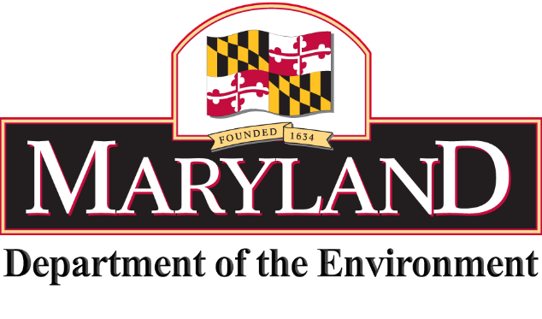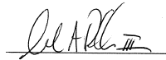­­

***MARINE CONTRACTORS LICENSING BOARD***

c/o MARYLAND DEPartment OF THE ENVIRONMENT

1800 Washington Blvd., Baltimore, MD 21230

(800) 633-6101, ext. 3249

CERTIFICATE OF COMPLETION

This is to certify that

*Company*

*Name*

has successfully completed the Maryland Contractors Licensing Board training course and is awarded 12 continuing education credit hours.

**MILTON A. REHBEIN, III, CHAIRMAN**

*MARINE CONTRACTOR*